|  |  |
| --- | --- |
| C:\Users\Office\Dropbox\Administration\Brochures\st pauls tower2.jpg | **St Paul’s Presbyterian Church**  “Partners in God’s Mission of Love” |

**NEWSLETTER – June 2021**

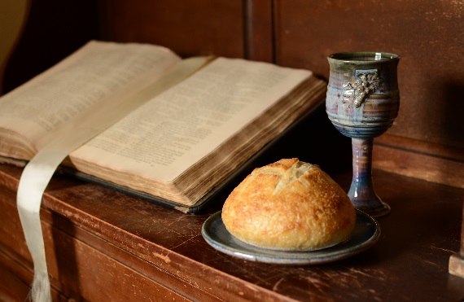

**“This do in remembrance of Me.”**

**Services of Holy Communion**

**June 13th 9:15 & 10:30**

**Please accept this as a personal invitation to be present.**

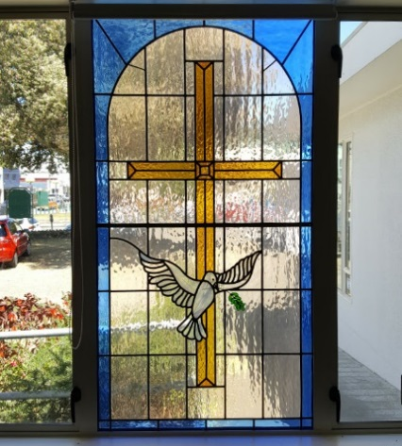

**Contents**

From the Minister’s Desk 2

Editorial 4

Moderator’s Pentecost Message 5

Hospital Chapel Service 6

Anne Frank Exhibition 7

Care and Share 9

A Family Refugee Story 9

Parish Register 11

Regular and Upcoming Events 11

Contact Us 12

# From the Minister’s Desk

Today as I write this it is a great day to be reflecting on the day of Pentecost.  The wind is gusty - a blustery day as Winnie the Pooh might describe it.  Palm branches have been broken off their trees by the strong winds.  A colleague was doing a burial up at Western Hills Cemetery as his robes billowed around and they nearly took off.  This is how the story of the day of Pentecost begins in Acts 2.  ‘A sound came from heaven.  A sound like a strong wind blowing and tongues of fire …Drama!

I was talking with a group of people the other day when someone said ‘What are you doing in your church for Pentecost?’  She was from Europe where Pentecost was a high feast day second only to Easter in its importance in the life of the Church.  In Eastern Orthodox circles, Pentecost is a weeklong observance including fasting, prayer and decorating the church with newly greening branches.

I wonder what sort of response we would get if we asked our friends ‘What are you doing for Pentecost?’ Even in England people get a Bank Holiday! Perhaps Matariki includes some of the elements of Pentecost - newness, reflection, celebration, hope and a holiday!

We in western Protestant churches have often allowed the celebration of Pentecost to slip under the radar, as the Holy Spirit, the so-called ‘shy’ member of the Trinity often takes third place to the Father and the Son.  Believe it or not, in 1054CE the Eastern Church split from the West over the Holy Spirit’s place in the Trinity!

If Easter is a 10 in terms of importance in our life as followers of the Way of Jesus, what is Pentecost for you?

For me, Pentecost is right up there, at least a 7!

Pentecost started out as a Hebrew Spring Harvest Festival, called the Feast of Weeks held 7 weeks and 1 day after the first day of Passover.  And for the Church it is 50 days after the Resurrection.  It is a feast of rich imagery … wind, fire, water, doves, and, my favourite, the Celtic symbol of the wild goose.  Sometimes God’s Spirit hovers comfortingly like a dove. But the Spirit also surprises us and disturbs our plans. Like a wild and unpredictable goose, the Holy Spirit sweeps in unexpected, astonishing directions

but importantly for us it is the gift of life, the gift of the Holy Spirit, the gift Jesus promised his followers.

The gift which makes the Church the Church.

The Holy Spirit has a full life - as an advocate, the Paraclete a reconciling, comforting, justice-seeking, compassionate Spirit which brings the peace, joy, unpredictability and fullness of life together in Christ.

Come, Holy Spirit!

**Sally**

**Editorial**

*Rae Wildbore and Pam Clare*

Who has one of those little old photo albums tucked away with pages full of very small black and white family photographs from another time and age? Viewing the Anne Frank exhibition made me think of a photo in my mother’s album which puzzled her family when received from an English aunt in the 1930s. Among the family members standing in their garden is a teenage girl, “a Jewish refugee staying with us” reads the caption. “Why?” wondered the New Zealand family, so far removed at that stage with what was taking place in Europe at the time.

St Paul’s has been very fortunate to host the Anne Frank exhibit which is in in Asher Hall until June 12th. It is a message to the young people of today, based on the diary written by a 15 year-old Jewish girl who has become a worldwide symbol for the millions of Jewish victims of the Holocaust.

Eleanor Holmes has shared with us a related family story, an account of her aunt’s escape from school in Austria, eventually arriving in London, and later meeting and marrying Eleanor’s uncle and settling in New Zealand. Eleanor accompanies the story with photos taken on a camera given to

her when she was ten. It took twelve photos on a spool and each photo was just two inches square. Very different from the iPad which she used to photograph Page 2 of her photo album for our newsletter!

The closing date for contributions to the September newsletter will be Monday, August 16th. Thank you as always to all contributors.

**Moderator’s Pentecost Message**

Jesus Taught: “If you love me, you will obey what I command. And I will ask the father, and he will give you another counsellor to be with you forever – the spirit of truth”

John 14: 15-16

Pentecost in Acts 2 is recognised and recalled as the coming of the Holy Spirit. The believers gathered in anticipation and in prayer. The Spirit came amongst them;

“They saw what seemed to be tongues of fire that separated and came to rest on each of them”. Acts 2:3. There are many who see this day as the beginning of the Church. It was an extraordinary day.

The day of Pentecost, a Jewish festival celebrating the wheat harvest, is known as the “Ingathering” or the “Harvest Festival”. It has been traditionally also called “The Feast of Weeks”. Today, it is celebrated as the day of the coming of the Holy Spirit.

Who is the Holy Spirit? For the majority of Christians, the Holy Spirit is the third person of the Triune God, Father, Son and Holy Spirit. The Spirit was there at the beginning of Creation. “And the Spirit of God hovered over the waters.” Genesis 1:2. The Spirit is recorded through Scripture as ever present. Jesus spoke clearly of the Holy Spirit, “Counsellor, teacher, comforter, provider, helper, spirit of truth...”. The Spirit will fulfil what Jesus taught.

The Holy Spirit is present in the world, and is present in you and me. In the resurrection narrative, as Jesus came amongst the disciples, he breathed on them and said, “Receive the Holy Spirit”. John 20:22. In baptism, we are baptised in, “The name of the Father and of the Son and of the Holy Spirit”. Matthew 28:19.

The Spirit of God is present to complete the work the Lord Jesus started, in each and every one of us. Jesus said, “The Counsellor will be with you forever”. John 14:16.

My beloved brothers and sisters in Christ, Pentecost is about the Holy Spirit. It is about Jesus’ teachings. We are Christians because we have accepted Jesus as our Lord and Saviour. We are baptised into the Father, Son and Holy Spirit. But what is crucial, every day, is to be in love with Jesus. And you and I will hence obey his commandments, and the Spirit of truth will be in you and I, all the days of our lives.

Jesus said, “Abide in me as I abide in you”. John 15:4.

Blessed Pentecost for you and for your loved ones.

Right Reverend Fakaofo Kaio

Moderator Presbyterian Church of Aotearoa New Zealand

[moderator@presbyterian.org.nz](mailto:moderator@presbyterian.org.nz)

**Hospital Chapel Service**

*Marian Eagle*

May 23rd was the Sunday our church took its turn to help at the weekly hospital chapel service held at the Hawke’s Bay Fallen Soldiers’ Memorial Hospital.  A big thank you to those people from the first service who did this on St Paul’s behalf. 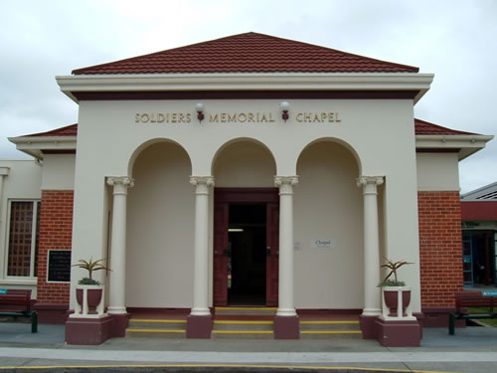

They assisted by using wheel chairs to move patients from the wards to the memorial chapel and then taking them back after the service.

We are helping again in September. If anyone feels they would be able to help please contact Marian Eagle. It would be much appreciated.

**Anne Frank Exhibition in Asher Hall**

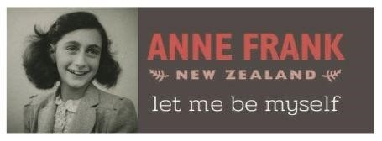

We have had a wonderful opportunity to host this exhibit which is going around the world from its base in Amsterdam.  Here is a description of the exhibition:

The Holocaust Centre of New Zealand is proud to announce that the new exhibition “Let Me Be Myself - The Life Story of Anne Frank” has been brought to NZ.  This Anne Frank exhibition is a message to the people of today, written by a 15-year-old Jewish girl who has become a worldwide symbol for the millions of Jewish victims of the Holocaust.

It shows the story of Anne Frank from her birth in 1929 up to her death in Bergen-Belsen concentration camp in 1945. Each panel also contains images and texts about the world around Anne Frank; the rise of Hitler, the Second World War and the persecution of Jews and other so called “undesirables.”

After a successful showing in Auckland, Wellington and Christchurch, the exhibition is now touring to other major cities and regional towns.

The exhibition is in line with the Holocaust Centre of New Zealand’s vision that through testimony and experience, we will inspire and empower individuals to stand against prejudice, discrimination and apathy. The Anne Frank exhibition makes clear the role that prejudice plays and how this can start small but lead to exclusion, discrimination and persecution.

This version contains a section in which young people of today address subjects like identity, exclusion and discrimination. The educational programme is based on peer education: secondary school students themselves give guided tours to their fellow students. The student guides have been given an extensive full day’s training covering basic Holocaust knowledge, Anne Frank’s story, how to interact with the exhibition, how to deal with difficult questions, and how to elicit answers using leading questions. This is an amazing opportunity to connect with our community in all its diversity and to explore important issues for our society.

The exhibition will be in Asher Hall until June 12th and will be open from 10:00am - 2:00pm from Tuesday - Friday.

*Dorothy Finlayson*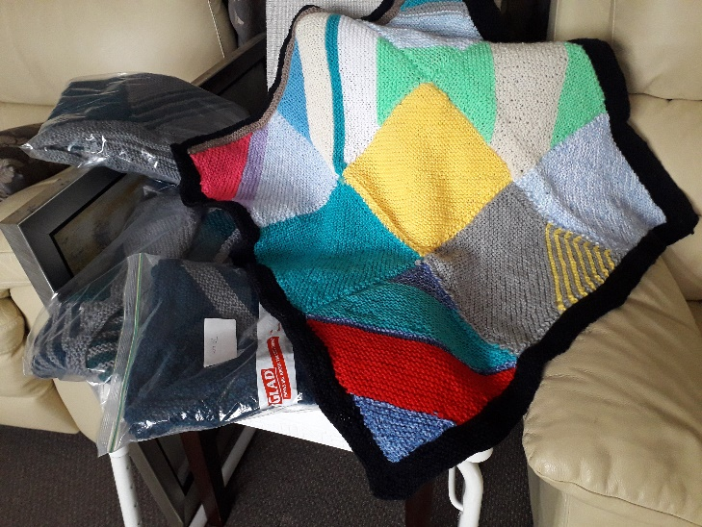

CARE AND SHARE

Our Care and Share group meet on the third Monday of each month. We would love you to join us for fun and fellowship. This year we have heard about travel and trips within New Zealand. If we can get wool, we will be knitting children’s warm rugs for Napier Family Centre and any needy families. We remember needy families and do as our name says, “Care and Share”. June promises to be fun with a Pea Pie and Pud luncheon in the Church lounge at 12noon on 21st June. Bring a friend and phone to book your space. Sales table is exciting so bring and/or buy. Any wool would be much appreciated for our knitting. For further information please contact Dorothy (06) 8431266 or [findot@xtra.co.nz](mailto:findot@xtra.co.nz)

**A Family Refugee Story**

*Eleanor Holmes*

Edith Lamb was my Aunt by marriage to Robert Cameron Lamb. Her story had a happy ending, unlike her parents who were imprisoned by German forces and exterminated. Edith was enabled to escape from her school in Austria. She told me she made her way through Poland, hiding in ditches, with mud on her face, hands and exposed skin to keep safe. After weeks her dress was filthy as well. When she reached the coast she was rescued by a Church group who smuggled her London.

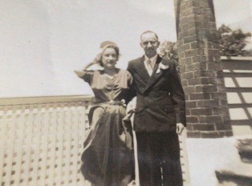

Edith and Robert on their Wedding Day

She was placed in a flat with girls from New Zealand and was given a bed by Wendy Doole. Wendy later became the wife of George Doole, my husband’s senior partner. Edith came to New Zealand as a refugee. She later met and married my Uncle Bob. After some years Edith was able to be reunited with her younger brother, Ernest, who had married an Ethiopian lady. Edith put him through medical school in Dunedin. He practiced medicine in Mangere until his death. Edith also found she had a living sister, residing in Colorado.

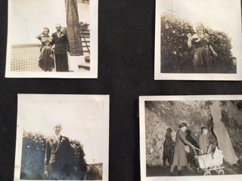

Bottom Right: Eleanor pushing her cousin

She and Uncle Bob had two children, Martin, a Professor of music in Perth and Karin a medical doctor in Christchurch.

**Humour**

God's Plan for Aging:

Most seniors never get enough exercise. In His wisdom God decreed that seniors become forgetful so they would have to search for their glasses, keys, and other things, thus doing more walking. And God looked down and saw that it was good.

Then God saw there was another need. In His wisdom He made seniors lose coordination so they would drop things, requiring them to bend, reach, and stretch. And God looked down and saw that it was good.

Then God considered the function of bladders and decided seniors would have additional calls of nature, requiring more trips to the bathroom, thus providing more exercise. God looked down and saw that it was good.

So, as you age, if you find that you are getting up and down more, remember it's God's will and that it’s all in your own best interest even though you mutter under your breath.

# Upcoming Events

Pizza dinner: **June 11th at** **5:30pm**. Celebrate our faith journeys - how you came to be part of our community of faith here at St Paul's.  Share our stories and enjoy a pizza dinner together.

Anne Frank Exhibition: On until June 12, 10am-2pm Asher Hall

|  |
| --- |
| **PARISH REGISTER** |
| *Rae Wildbore* |
| Funeral: Takamoa Cowley died 7th March 2021. |
| Victor Brian Heath died 29 April 2021 (Service at Dunstall’s Chapel). |
| We extend our loving sympathy to the families and friends of Takamoa and Vic. |

# Contact Us

Phone: 06 835 5359

email: [stpaulsnapier@gmail.com](mailto:stpaulsnapier@gmail.com)

Street Address: 89 Tennyson Street, Napier

Postal Address: P O Box 310, Napier, 4140

Website: [www.stpaulsnapier.org.nz](http://www.stpaulsnapier.org.nz/)



You can also check us out on Facebook.

[St Paul's Presbyterian Church, Napier - Home | Facebook](https://www.facebook.com/St-Pauls-Presbyterian-Church-Napier-211359838877546/)

This newsletter was delivered by ……………………………

Phone ..........................................

Please feel free to phone me with any questions or if you would like a visit.